Lab 3

Records Output to Console

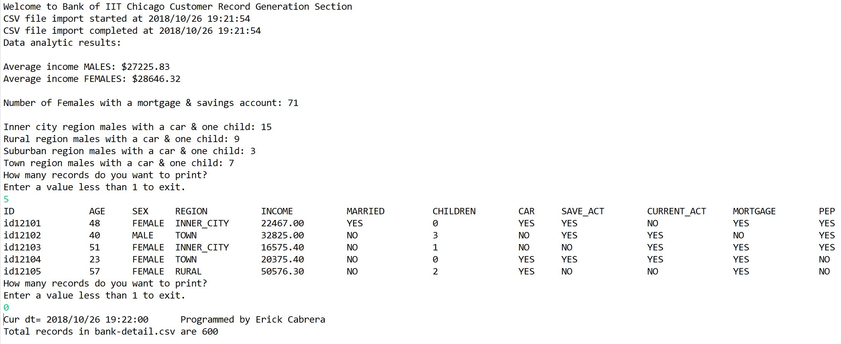

Records Output to Text File

